# Flow Documentation - 0504_Projeto_Ferias-49DC2D45-2BF3-EE11-A1FD-000D3A65976C

|  |  |
| --- | --- |
| **Flow Name** | 0504_Projeto_Ferias-49DC2D45-2BF3-EE11-A1FD-000D3A65976C |
| **Documentation generated at** | Wednesday, April 17, 2024 2:58 PM |
| **Number of Variables** | 0 |
| **Number of Actions** | 1 |

## Flow Overview

The following chart shows the top level layout of the Flow. For a detailed view, please visit the section called Detailed Flow Diagram

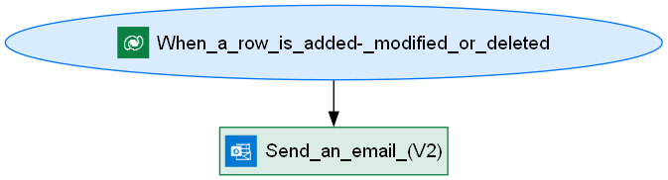

## Connections

There are a total of 2 connections used in this Flow:

### shared

|  |  |
| --- | --- |
| **Connector** | [shared](https://docs.microsoft.com/connectors/shared) |
| **Connection Type** | ConnectorReference |
| **Connection Reference Name** | new_sharedcommondataserviceforapps_52ba3 |
| **Source** | embedded |

## Variables

## Trigger

|  |  |
| --- | --- |
| **Name** | When_a_row_is_added,_modified_or_deleted |
| **Type** | OpenApiConnectionWebhook |
| **Connector** | commondataserviceforapps |
| **Inputs Details** | |
| **parameters** | |  |  | | --- | --- | | subscriptionRequest/message | 1 | | subscriptionRequest/entityname | crfed_cadastro | | subscriptionRequest/scope | 4 | | subscriptionRequest/name | 49dc2d45-2bf3-ee11-a1fd-000d3a65976c | |
| **host** | |  |  | | --- | --- | | apiId | /providers/Microsoft.PowerApps/apis/shared_commondataserviceforapps | | operationId | SubscribeWebhookTrigger | | connectionName | shared_commondataserviceforapps | |

## Actions

There are a total of 1 actions used in this Flow:

### Send_an_email_(V2)

|  |  |
| --- | --- |
| **Name** | Send_an_email_(V2) |
| **Type** | OpenApiConnection |
| **Connection** | |  |  | | --- | --- | |  | [Office 365 Outlook](https://docs.microsoft.com/connectors/office365) | |
| **Inputs** | |
| **parameters** | |  |  | | --- | --- | | emailMessage/To | @triggerBody()?['crfed_email'] | | emailMessage/Subject | Welcome to Power Gym Girls! | | emailMessage/Body | <p>Hello @{triggerBody()?['crfed_fullname']}!</p><br><p>We welcome you to our gym. Here is the info you provided in your registration:</p><br><p>Full Name: @{triggerBody()?['crfed_fullname']}</p><p>Idade: @{triggerBody()?['new_idade']}</p><p>Job Title: @{triggerBody()?['crfed_jobtitle']}</p><p>City: @{triggerBody()?['crfed_city']}</p><br><p>With best regards,</p><br><p><b><strong style="color: rgb(144, 19, 254);">Power Gym Girls</strong></b></p> | | emailMessage/Importance | Normal | |
| **host** | |  |  | | --- | --- | | apiId | /providers/Microsoft.PowerApps/apis/shared_office365 | | operationId | SendEmailV2 | | connectionName | shared_office365 | |

## Detailed Flow Diagram

The following chart shows the detailed layout of the Flow

